Puzzle +Java Topics to Covered

18 August 2023

07:36

Puzzle -1

T20 Match

Puzzle -2

Cross the bridge

(1 ,2 ,5 ,8)

1.What is algorithms?

2.Why java?

* Basics syntax
* Comments in java
  + Single line
  + Multi line

* Variables in java
  + How to declare a variable
  + Variable name start with(character only,_)
* Operators
* Decision making
* Loops

3.why OOPs

How JAVA code executed

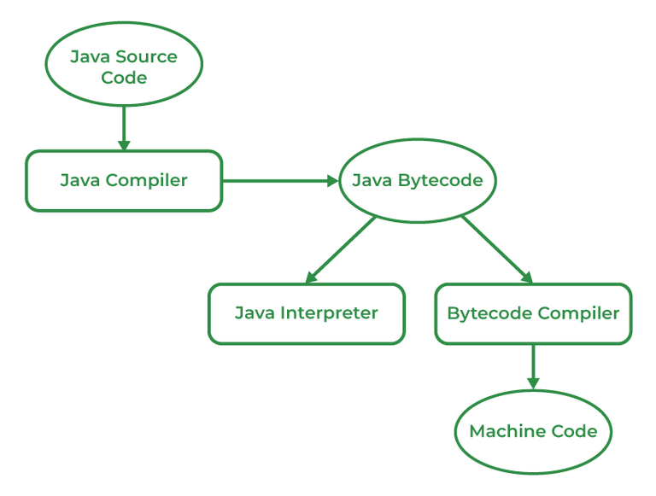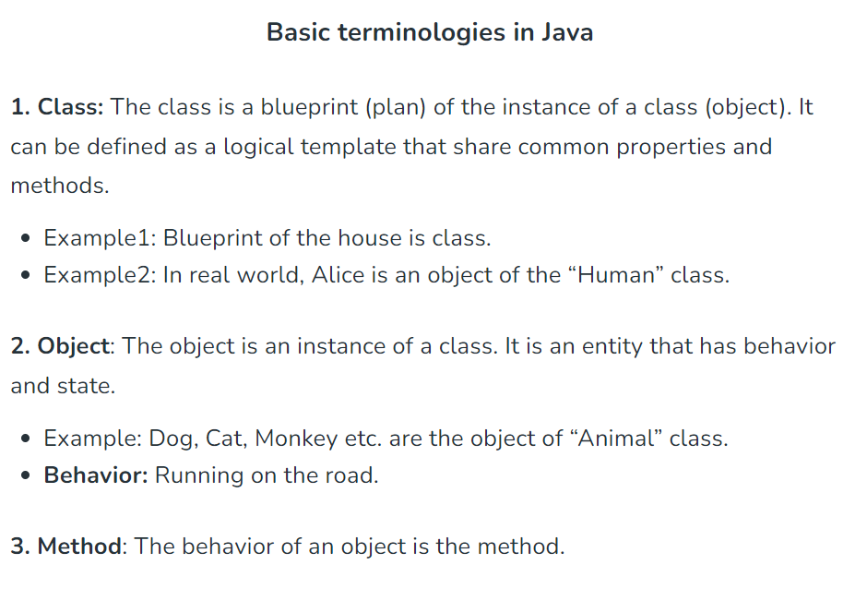

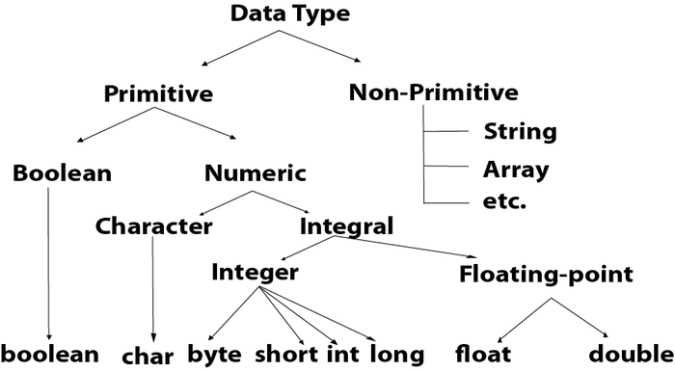

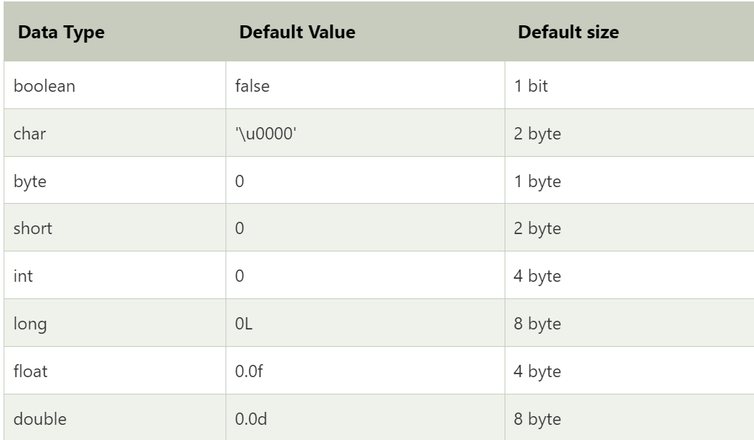

* + Some Basics Program Practice
  + Print number
  + Print String
  + And many more

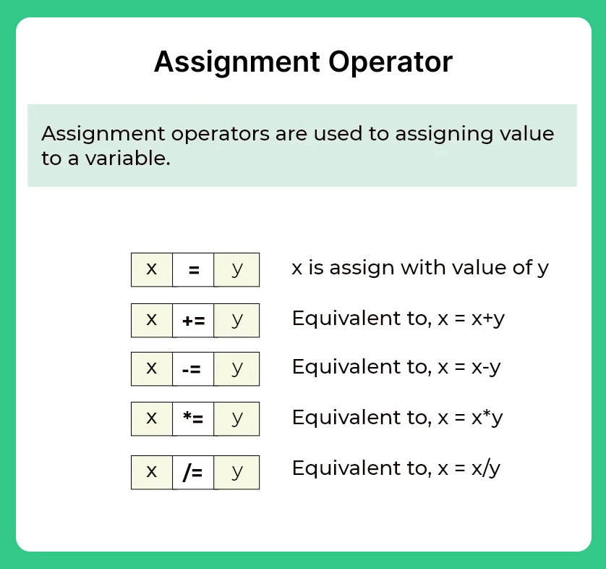

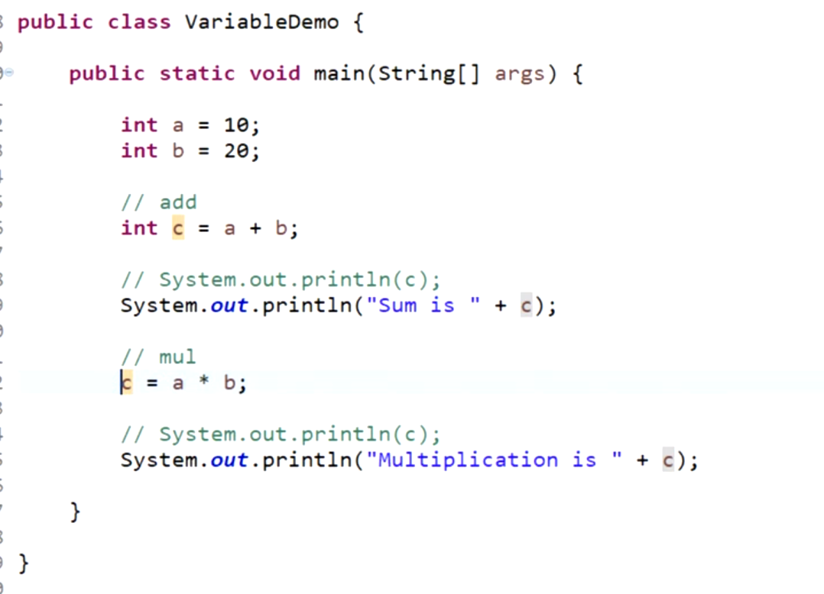



* + We cannot re-initialize variable with the same name

* + Simple Interest Program.(p=1000,R=5,T=2)

Ans:-(1000*5*2)/100=100;

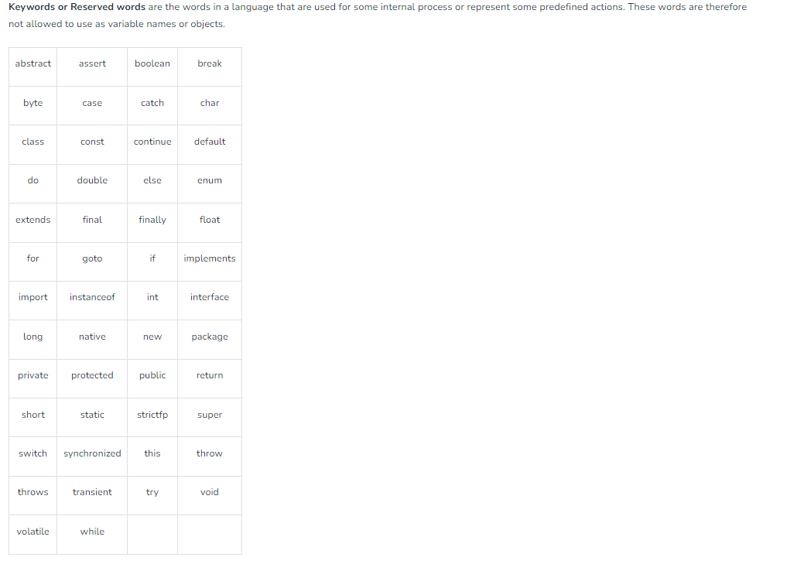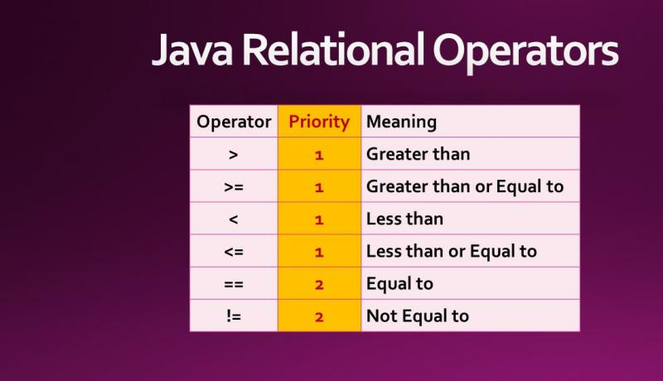

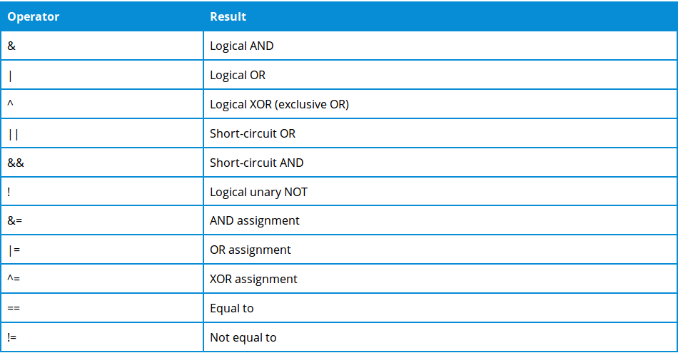

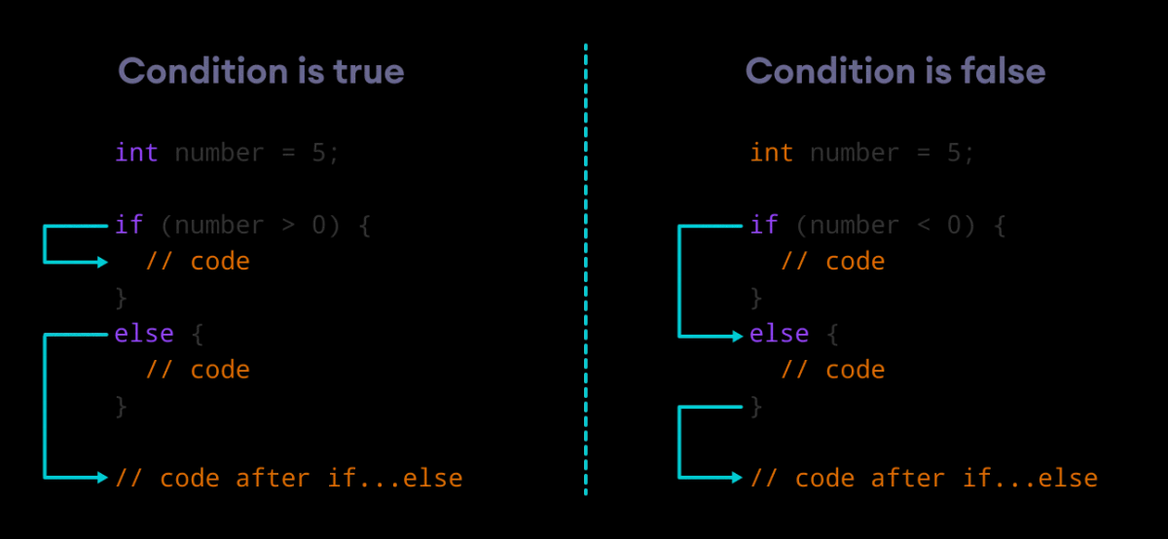

* 1. **EVEN ODD Program**

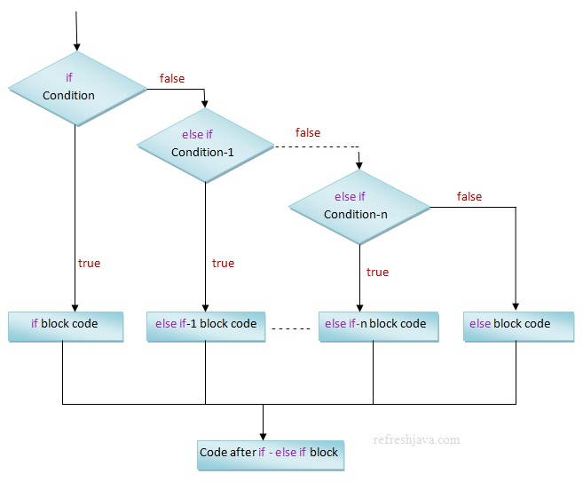

Operators (&&,|| and more)

Q)fizz, buzz pint

->if elseif

else

Topic:-take input from user using scanner class

* Integer input
* String input
* Float input
* Double input

LOOP(4 class)

* For loop
* While loop
* Do while loop
* Diff between
  + break
  + continue
  + return
* Modulo operator(%)

Q)Sum of n natural numbers

* Prime number Code
* Print digits of a number
* Sum of all digits of a number
* Armstrong Number
* Max of all the digits of a number
* Reverse the number
* GCD of number
* Fibonacci series



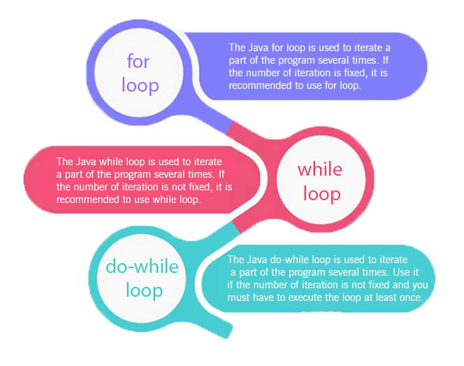



Pattern Practice Question( one week)

* P1
* P2
* P3
* ……p33

Type conversion

* 1. Binary to decimal
  2. Decimal to Binary

Q.)Assignment 1(CB)

* 1. GCD
  2. Prime Number
  3. Nth Fibbonacci
  4. Inverse of a number
  5. Sum of Digits of number

Q)Assignment 2(All must be solved using function)

* 1. Pattern Question (Practice by students)

Function

* 1. How to define a function
  2. Inbuilt function

Arrays

* 1. 1-D arrays
     + Array declaration
     + Taking user input in array
     + Array printing
     + Find odd even in an array
     + Reverse printing of an Array

All Question must be solved using function

* 1. Max in array(inbuilt (inbuilt max function)
  2. Min in array(inbuilt min function)
  3. Check Palindrome in Array
  4. Reverse Array (3 Approach)
  5. Rotate array(2 Approach)
  6. Inverse of an array
  7. Odd even count
  8. Searching
     + Linear search (code for Linear Search )
     + Binary search (Explanation with code )
  9. Sorting(inbuilt sort function)
     + Insertion
     + Bubble
     + Selection
  10. SubArray sum Concept
      + Max subarray sum
  11. Swapping
      + Pass by value
      + Pass by reference
      + Pass by index

* 1. 2-D arrays
     + Matrix representation
     + Take input in matrix
     + Matrix print
     + Wave print
     + Spiral print
     + Search in 2D array

String and String Builder

* 1. String
     + String Declaration(Normal ,Using new keyword)
     + Traverse on String (Print character of String)
     + Check Vowel of String (Print vowel ,Consonant)
     + Check Palindrome of String
     + String inbuilt function
       1. Length()
       2. Concat()
       3. Cocatenation using + operator
       4. toLowerCase()
       5. toUpperCase()
       6. Trim()
       7. Replace(original char,new char)
       8. Str.substring(5),str.substring(5,9) 9 not included

* 1. Check two string are equal or not?
  2. And many more question practice

String Builder

StringBuilder in Java is a class used to create a mutable, or in other words, a modifiable succession of characters. Like StringBuffer, the StringBuilder class is an alternative to the Java Strings Class, as the Strings class provides an immutable succession of characters.

**Understanding Access Modifiers:**

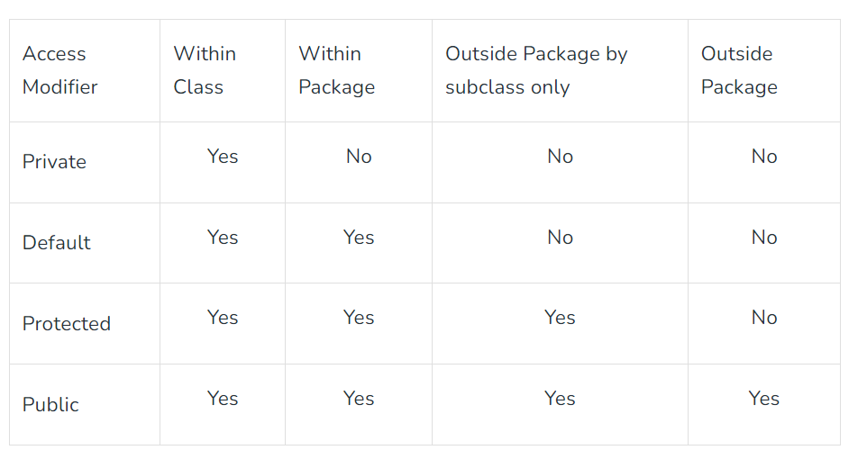

Advanced Practice

1.Rotate Array by K

<https://leetcode.com/problems/rotate-array/>

2.Square of a sorted Array

<https://hack.codingblocks.com/app/contests/5039/1943/problem>

Concept

How to make Character Array

1. String s1="hello";
2. **char**[] ch=s1.toCharArray();
3. **for**(**int** i=0;i<ch.length;i++){
4. System.out.print(ch[i]);
5. }

3. find the non-repeating character

<https://hack.codingblocks.com/app/contests/4198/563/problem>

4.Find Majority Element in Array

Arrays

1. Subarray Concept Sum
2. Subarray Sum equal to zero or subarray sum k
3. Sort 0 1 (<https://hack.codingblocks.com/app/contests/5039/18/problem>)
4. Sort 0 1 2(https://hack.codingblocks.com/app/contests/5039/1330/problem)

Java String class methods

The java.lang.String class provides many useful methods to perform operations on sequence of char values.

|  |  |  |
| --- | --- | --- |
| **No.** | **Method** | **Description** |
| 1 | [char charAt(int index)](https://www.javatpoint.com/java-string-charat) | It returns char value for the particular index |
| 2 | [int length()](https://www.javatpoint.com/java-string-length) | It returns string length |
| 3 | [static String format(String format, Object... args)](https://www.javatpoint.com/java-string-format) | It returns a formatted string. |
| 4 | [static String format(Locale l, String format, Object... args)](https://www.javatpoint.com/java-string-format) | It returns formatted string with given locale. |
| 5 | [String substring(int beginIndex)](https://www.javatpoint.com/java-string-substring) | It returns substring for given begin index. |
| 6 | [String substring(int beginIndex, int endIndex)](https://www.javatpoint.com/java-string-substring) | It returns substring for given begin index and end index. |
| 7 | [boolean contains(CharSequence s)](https://www.javatpoint.com/java-string-contains) | It returns true or false after matching the sequence of char value. |
| 8 | [static String join(CharSequence delimiter, CharSequence... elements)](https://www.javatpoint.com/java-string-join) | It returns a joined string. |
| 9 | [static String join(CharSequence delimiter, Iterable<? extends CharSequence> elements)](https://www.javatpoint.com/java-string-join) | It returns a joined string. |
| 10 | [boolean equals(Object another)](https://www.javatpoint.com/java-string-equals) | It checks the equality of string with the given object. |
| 11 | [boolean isEmpty()](https://www.javatpoint.com/java-string-isempty) | It checks if string is empty. |
| 12 | [String concat(String str)](https://www.javatpoint.com/java-string-concat) | It concatenates the specified string. |
| 13 | [String replace(char old, char new)](https://www.javatpoint.com/java-string-replace) | It replaces all occurrences of the specified char value. |
| 14 | [String replace(CharSequence old, CharSequence new)](https://www.javatpoint.com/java-string-replace) | It replaces all occurrences of the specified CharSequence. |
| 15 | [static String equalsIgnoreCase(String another)](https://www.javatpoint.com/java-string-equalsignorecase) | It compares another string. It doesn't check case. |
| 16 | [String[] split(String regex)](https://www.javatpoint.com/java-string-split) | It returns a split string matching regex. |
| 17 | [String[] split(String regex, int limit)](https://www.javatpoint.com/java-string-split) | It returns a split string matching regex and limit. |
| 18 | [String intern()](https://www.javatpoint.com/java-string-intern) | It returns an interned string. |
| 19 | [int indexOf(int ch)](https://www.javatpoint.com/java-string-indexof) | It returns the specified char value index. |
| 20 | [int indexOf(int ch, int fromIndex)](https://www.javatpoint.com/java-string-indexof) | It returns the specified char value index starting with given index. |
| 21 | [int indexOf(String substring)](https://www.javatpoint.com/java-string-indexof) | It returns the specified substring index. |
| 22 | [int indexOf(String substring, int fromIndex)](https://www.javatpoint.com/java-string-indexof) | It returns the specified substring index starting with given index. |
| 23 | [String toLowerCase()](https://www.javatpoint.com/java-string-tolowercase) | It returns a string in lowercase. |
| 24 | [String toLowerCase(Locale l)](https://www.javatpoint.com/java-string-tolowercase) | It returns a string in lowercase using specified locale. |
| 25 | [String toUpperCase()](https://www.javatpoint.com/java-string-touppercase) | It returns a string in uppercase. |
| 26 | [String toUpperCase(Locale l)](https://www.javatpoint.com/java-string-touppercase) | It returns a string in uppercase using specified locale. |
| 27 | [String trim()](https://www.javatpoint.com/java-string-trim) | It removes beginning and ending spaces of this string. |
| 28 | [static String valueOf(int value)](https://www.javatpoint.com/java-string-valueof) | It converts given type into string. It is an overloaded method. |